**Topic: Mongodb Commands**

**Aim:** Write Mongodb Commands

**Introduction:** MongoDb, the most popular NoSQL database, is an open-source document-oriented database. The term ‘NoSQL’ means ‘non-relational’. It means that MongoDB isn’t based on the table-like relational database structure but provides an altogether different mechanism for storage and retrieval of data .This format of storage is called BSON (similar to JSON format).

**All MongoDb commands and Output :**

1. To Run the Mongo.

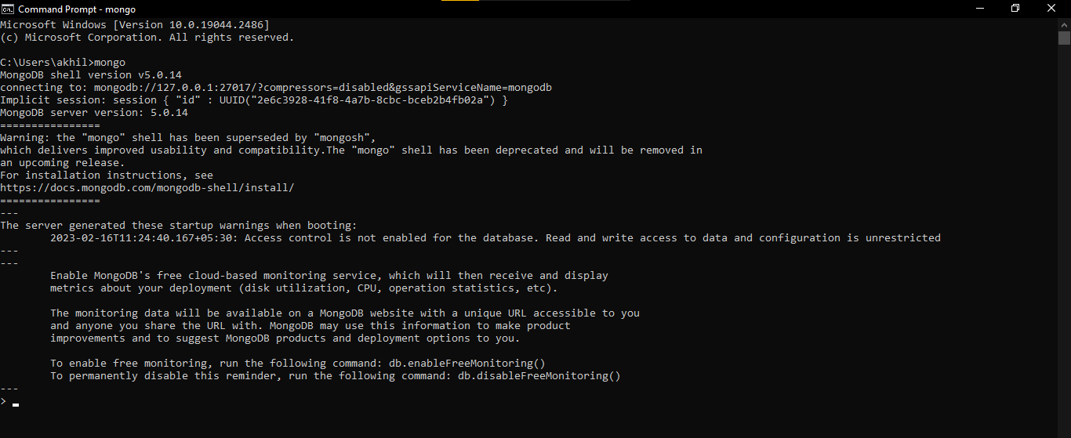

2. View all databases.

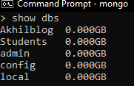

3. Creating a new or switch databases.



4. View current Database.



5. Delete Database.

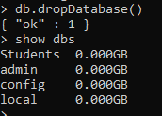

6. Show Collections.



7. Creating a collection named ‘stud_data’.



8. Drop or Deleting a collection named ‘stud_data’.



9. Show all Rows in a Collection.



10. Show all Rows in a Collection(Prettified).

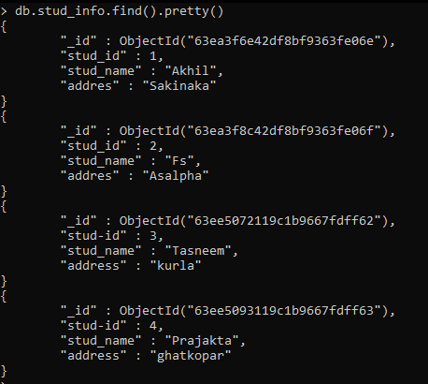

11. Insert a Row.

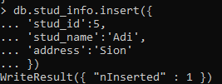

12. Mongodb Rename Operator.



13. Deleting Row.



14. Count the number of rows in the output.



15. Search in a MongoDb Database.

